|  |  |  |
| --- | --- | --- |
| Web 1.0 | Web 2.0 | Web 3.0 |
| First phase of the World Wide Web | Current phase of the web dominated by social networking | Future of the internet |
| Read-only web | Read-Write web | Read-Write-Interact |
| Static webpages with page hyperlinking and bookmarking as their major functionality | Dynamic content with high responsiveness to user inputs | Blockchain, cryptocurrency and metaverse are the cardinal features |
| No data collection; content comes from a server to be consumed by the client. | Tech giants like Meta, Google, Amazon, Microsoft control how our personal data will be used to produce user-generated content. | Data will reside on the blockchain network, therefore users will in control of their data. The owners get to decide the ways in which they want to share. A decentralised way of internet |
| The websites had little to no interaction capabilities | Social media, social networking, tagging, blogging, podcasts, web-content voting | More personalised surfing experience, smarter search engines and decentralised benefits |
|  | Mass surveillance, little to no privacy and security | Leverages encryption and distributed ledger technology to address challenges related to trust, privacy, security. |
|  | Personal data is vulnerable to attacks by hackers or malicious ransomware | Use of advanced authorization mechanisms for the protection of user data and identity. |
| One-directional | Participative and social web | Immersive, virtual reality |

**Evolution of Web**

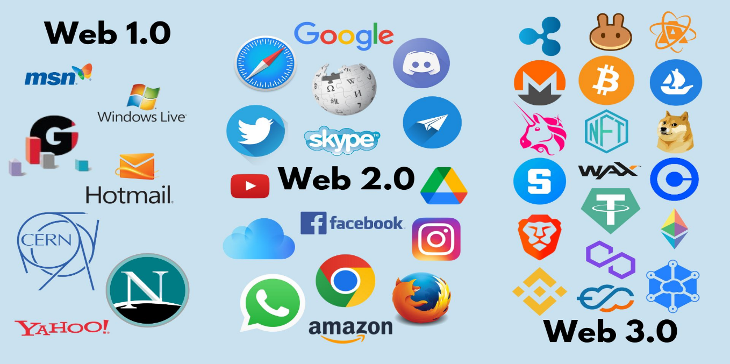

**Blockchain**

* Blockchain is an innovative, decentralised and distributive ‘State-of-the-art’ technology which maintains confidentiality, integrity and availability of all transactions and data.
* It is a shared, open and distributed ledger that can help store record data and transactions backed by cryptographic hash value across peer-to-peer network.
* Blockchain is a digital shared network which is distributed over the network. It consists of a sequence of blocks which holds a complete list of transaction records like a conventional public ledger. The blocks are connected to each other by a cryptographic hash function which links each block to its previous block.
* The first block of a blockchain is called **genesis block** which has no parent block.

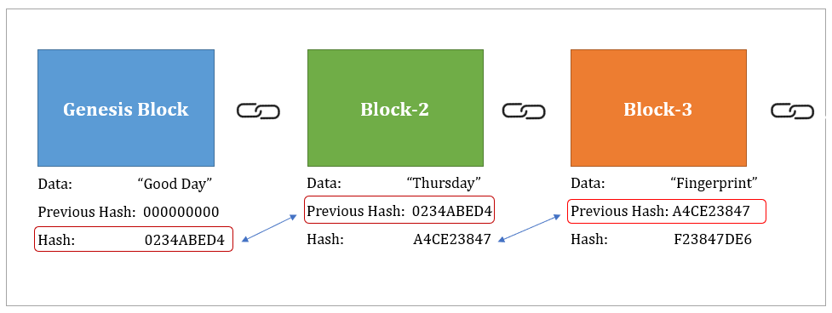

* A hash is like a fingerprint, it is a 256-bit hash value that points to the previous block.
* **Characteristics of Blockchain**
* **Decentralisation** – a transaction in the blockchain network can be conducted between any two peers (P2P) without the authentication by the central agency thus reducing costs and mitigating performance bottlenecks.
* **Anonymity** – There is no longer a central party keeping user’s private information, this mechanism preserves a certain amount of privacy on the transactions included in the blockchain.
* **Immutability** – Since the transactions are stored in different nodes in the distributed network, it is nearly impossible to tamper with the blockchain.
* **Security enhancement**
* **Data transparency and auditability**
* **Privacy protection**
* **Data ownership**
* **Fine-grained access control**
* **Applications of Blockchain**
* **Asset management –** Blockchain removes the need for any intermediaries such as brokers, banks and provides a simple, transparent process that removes the chances of error.
* **Healthcare** – personal health records are only accessible to primary healthcare providers with a key which ensures that patient information is confidential and not accessible to anyone.
* **Cryptocurrency –** no geographical limitations, no exchange rates, no need for a central banking facility, no reliance on economy, money can be exchanged with anyone.
* **Internet Of Things (IoT) –** IoT is a network of interconnected devices that can interact with others and collect data that can be used for gaining useful insights. Blockchain can ensure that the data obtained by the IoT devices are secure and visible to only trusted parties.
* **Logistics and supply chain management -** Supply chain networks can be limited by one-up/one-down visibility. Through distributed ledger technology that provides a shared, single version of the truth, blockchain supply chain solutions give permissioned participants greater visibility across all supply chain activities

**Sybil Attack**

A type of malicious assault that targets peer to peer (P2P) networks. It involves a single node operating multiple identities at the same time and undermines the authority/power in the reputation systems. It tries to take over the network by creating multiple accounts, nodes or computers.

Many blockchains use different consensus algorithms such as Proof of Work, Proof of Stake and Delegated proof of Stake to help defend against sybil attacks.

**Crowdsourcing**

* It is a sourcing model in which an individual or an organisation gets support from a large, open-minded and rapidly evolving group of people in the form of ideas, micro-tasks and finances. It typically involves the use of internet to attract a large group of people to divide tasks or achieve a target.
* Crowdsourcing can help different types of organisations to get new ideas and solutions, deepen consumer engagement, optimization of tasks and several other things.
* Some fields where crowdsourcing is used – enterprise, IT, marketing, education, finance, science and health.
* Examples of crowdsourcing platforms – Amazon Mechanical Turk, Upwork, Fiverr

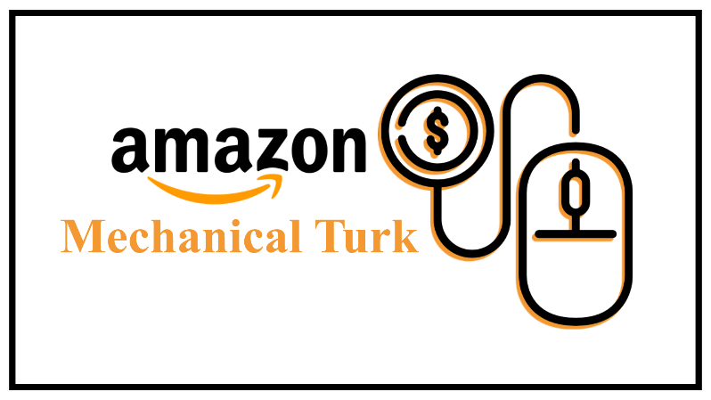

**Cloud Computing**

Cloud computing is the on-demand availability of computer-system resources especially data storage and computing power without the direct management by the user.

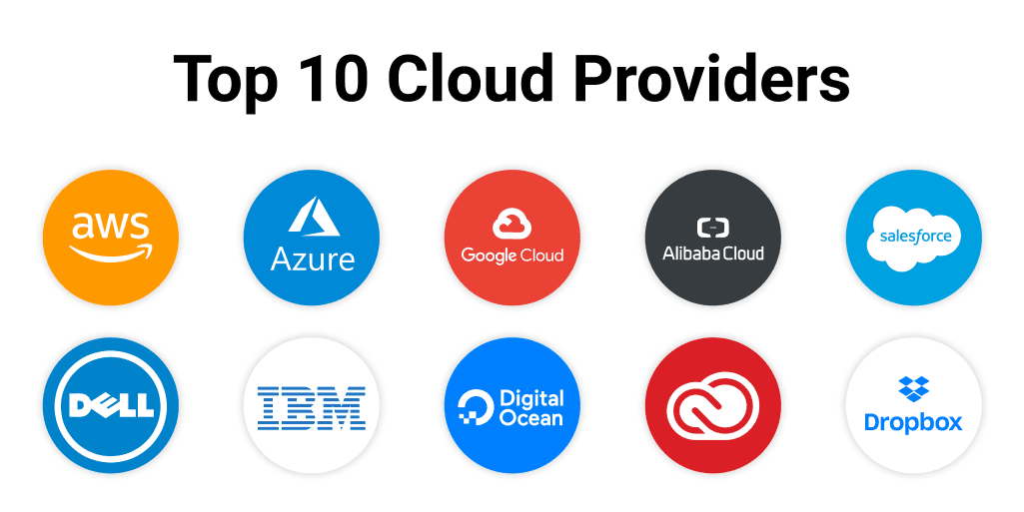

**Advantages**

* Agility – access to a broader range of technologies so that one can innovate faster and build nearly anything one can imagine.
* Elasticity – one can scale the resources up or down to instantly grow and shrink capacity to comply with business changes.
* Cost savings – most cloud service providers have nominal costs and they have a ‘pay-as-you-go’ model
* Deploy globally in minutes (Scalability) – cloud service providers have data centred and infrastructure all over the world so one deploys applications in multiple locations.

**Disadvantages**

* Data integrity – data is mutable when it is stored in a server.
* Centralised trust assumption